# Story 4. Show selected spot

As a registered user  
I want to see my reserved spot  
so that I can see what my spot is and what my selected options are.

## Acceptance criteria:

* Show a message if I didn’t reserve a spot yet.
* Show my spot if I already have a spot.
* Show the options that I selected.

## Wireframes:

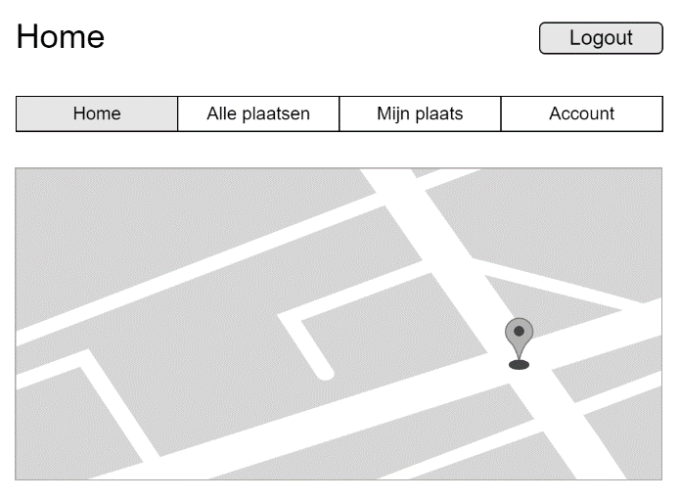

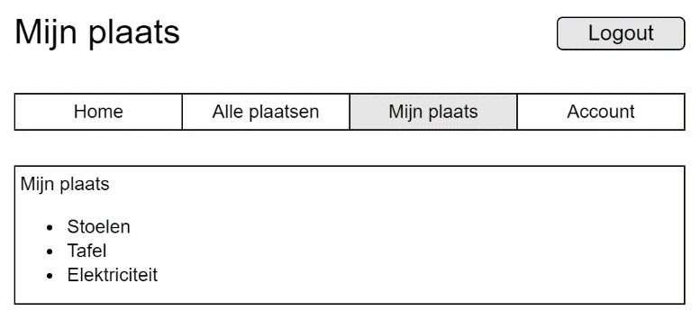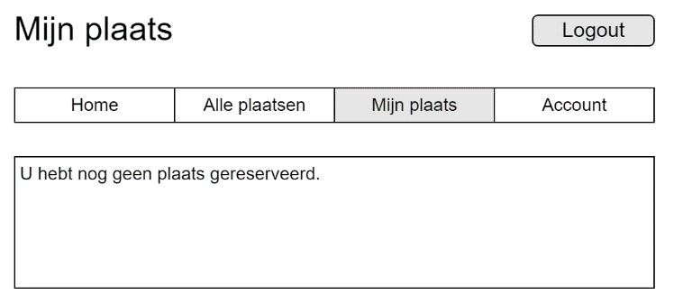

Already a spot

No spot yet